|  |  | **CL118** | | | | **Lab 10** |
| --- | --- | --- | --- | --- | --- | --- |
|  |  |  |  |  |  |  |
|  | **Programming** | | | | | Recursion & Structures |
|  |  | | |  |  |  |
| **Fundamentals** | | | | | |  |
|  |  |  |  |  |  |  |

**Instructors:**

**NATIONAL UNIVERSITY OF COMPUTER AND EMERGING SCIENCES**

**LAB 10**

**Learning Objectives**

This lab will cover the following topics:

* Recursion
* Structures

**Recursion**

When a function invokes itself, the call is known as a recursive call. Recursion (the ability of a function to call itself) is an alternative control structure to repetition (looping). Rather than use a looping statement to execute a program segment, the program uses a selection statement to determine whether to repeat the code by calling the function again or to stop the process.

**Flowchart for recursion:**

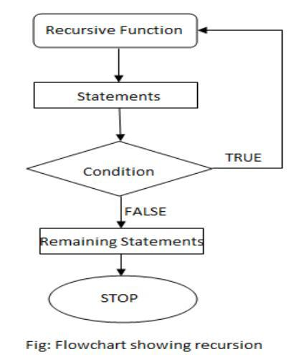

Each recursive solution has at least two cases: the base case and the general case.

The **base case** is the one to which we have an answer; the **general case** expresses the solution in terms of a call to itself with a smaller version of the problem. Because the general case solves a smaller and smaller version of the original problem, eventually the program reaches the base case, where an answer is known, and the recursion stops.

For example, a classic recursive problem is the factorial. The factorial of a number is defined as the number times the product of all the numbers between itself and 0: N! = N * (N-1)! The factorial of 0 is 1. We have a base case, Factorial (0) is 1, and we have a general case, Factorial (N) is N * Factorial (N-1). An if statement can evaluate N to see if it is 0 (the base case) or greater than 0 (the general case). Because N is clearly getting smaller with each call,



1 | P a g e

The base case is reached.

Following is the recursive version of the function to calculate the factorial value.

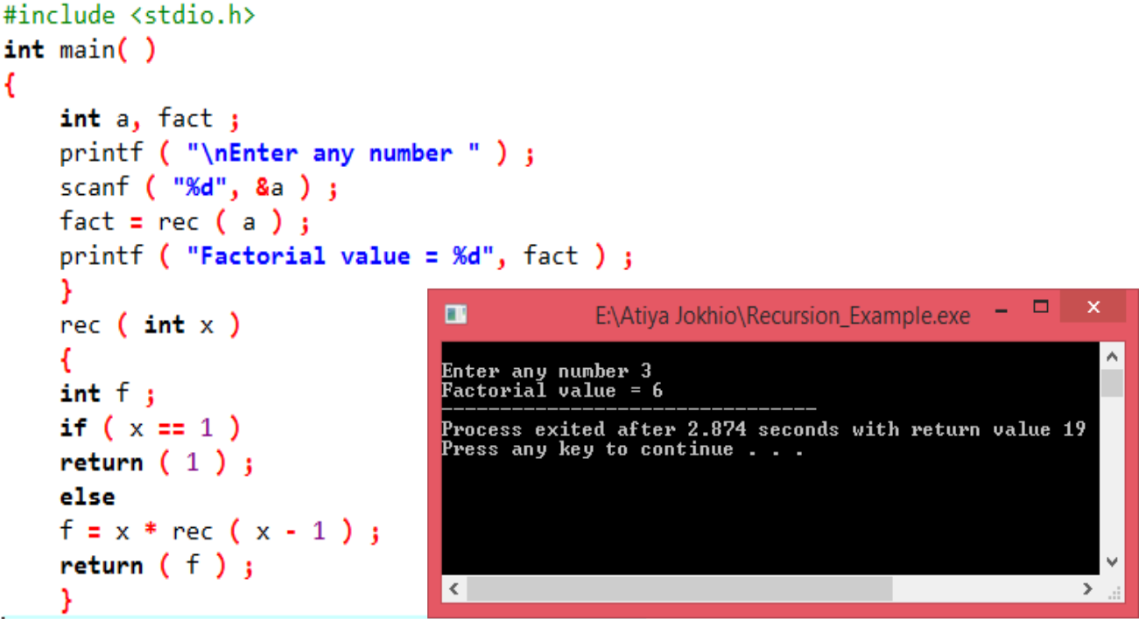

Assume that the number entered through scanf( ) is 3. The figure below explains what exactly happens when the recursive function rec( ) gets called.

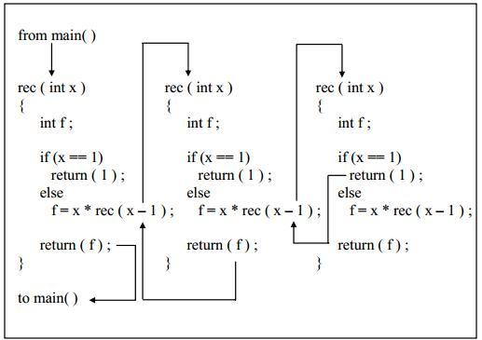

2 | P a g e

**Disadvantages of recursion**

– Recursive programs are generally slower than non-recursive programs. This is because,recursive function needs to store the previous function call addresses for the correct

Program jump to take place.

– Requires more memory to hold intermediate states. It is because, recursive programrequires the allocation of a new stack frame and each state needs to be placed into the stack frame, unlike non-recursive (iterative) programs.

**Structures:**

We studied earlier that array is a data structure whose element are all of the same data type. Now we are going towards structure, which is a data structure whose individual elements can differ in type. Thus a single structure might contain integer elements, floating– point elements and character elements. Pointers, arrays and other structures can also be included as elements within a structure. The individual structure elements are referred to as members. This lesson is concerned with the use of structure within a 'c' program. We will see how structures are defined, and how their individual members are accessed and processed within a program. The relationship between structures and pointers, arrays and functions will also be examined. Closely associated with the structure is the union, which also contains multiple members.

In general terms, the composition of a structure may be defined as

struct tag

{ member 1; member 2;

------------

-------------

member m; }

In this declaration, struct is a required key-word; tag is a name that identifies structures of this type. The individual members can be ordinary variables, pointers, arrays or other structures. The member names within a particular structure must be distinct from one another, though a member name can be same as the name of a variable defined outside of the structure.

A storage class, however, cannot be assigned to an individual member, and individual members cannot be initialized within a structure-type declaration. For example:

struct student

{

char name [80];

introll_no;

float marks;

};

We can now declare the structure variable s1 and s2 as follows:

struct student s1, s2;

s1 and s2 are structure type variables whose composition is identified by the tag student.

It is possible to combine the declaration of the structure composition with that of the structure variable as shown below.

storage- class struct tag

{

member 1;

member 2;

1. ——
2. —-
3. member m;

} variable 1, variable 2 --------- variable n;

The tag is optional in this situation.

struct student {

char name [80];

introll_no;

float marks;

} s1, s2;

The s1, s2, are structure variables of type student. Since the variable declarations are now combined with the declaration of the structure type, the tag need not be included. As a result, the above declaration can also be written as

struct {

char name [80];

introll_no;

float marks ;

} s1, s2;

A structure may be defined as a member of another structure. In such situations, the declaration of the embedded structure must appear before the declaration of the outer structure. The members of a structure variable can be assigned initial values in much the same manner as the elements of an array. The initial values must appear in the order in which they will be assigned to their corresponding structure members, enclosed in braces and separated by commas. The general form is

storage-classstruct tag variable = { value1, value 2,-------,value m};

A structure variable, like an array can be initialized only if its storage class is either external or static. e.g. suppose there are one more structure other than student.

structdob

{

Intmonth; int day; int year; };

struct student

{ char name [80]; introll_no; float marks; structdob d1; };

staticstruct student st = { “ali”, 2, 99.9, 17, 11, 01};

**PROCESSING A STRUCTURE**

The members of a structure are usually processed individually, as separate entities. Therefore, we must be able to access the individual structure members. A structure member can be accessed by writing

variable.member name

This period (.) is an operator, it is a member of the highest precedence group, and its associativity is left-to-right.

E.g. if we want to print the detail of a member of a structure then we can write as printf(“%s”,st.name); or printf(“%d”, st.roll_no) and so on. Morecomplex expressions involving the repeated use of the period operator may also be written. For example, if a structure member is itself a structure, then a member of the embedded structure can be accessed by writing:

variable.member.submember

Thus in the case of student and dob structure, to access the month of date of birth of a student, we would write

st.d1.month.

***Question 1:***

Write a program in C to multiply two matrix using recursion.

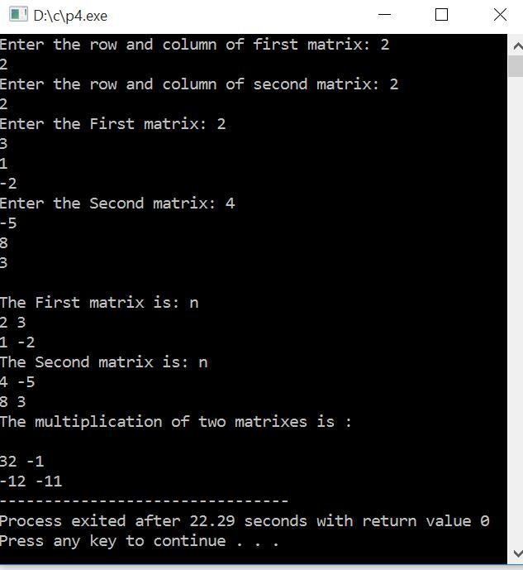

***Question 2:***

Write a recursive implementation of the factorial function.  Recall that n!  =  1  ×  2  ×  …  ×  n, with  the  special  case  that  0!  = 1.

***Question 3:***

Write  a  recursive  function  that,  given  two  strings,  returns  whether  the  first  string  is  a subsequence  of  the  second.  For  example,  given  har  and  cathartic,  you  should  return  true, but  given  bat  and  table,  you  should  return  false.

***Question 4:***

Write  a  recursive  function  that  checks  whether  a  string  is  a  palindrome  (a  palindrome  is a  string  that's  the  same  when  reads  forwards  and  backwards.)

**Question 5:**

**Consider an array given below:**

**A [10] = {5, 4, 3, 2, 1, 6, 10, 9, 7, 8}**

**Your task is to write a recursive function that searches a given element from that array.**

***Question 6:***

A phone number, such as (212) 767-8900, can be thought of as having three parts: e.g., the area code (212), the exchange (767), and the number (8900). Write a program that uses a structure to store these three parts of a phone number separately. Call the structure phone.

Create two structure variables of type phone. Initialize one, and have the user input a number for the other one. Then display both numbers.

The interchange might look like this:

Enter area code: 415

Enter exchange: 555

Enter number: 1212

Then display like below:

My number is (212) 767-8900

Your number is (415) 555-1212

**Question 07:**

Define a structure to store the following student data:

CGPA, courses (course name, GPA), address (consisting of street address, city, state, zip). Input 2 student records, compare and display which student have highest GPA in which course also Display which student has the highest CGPA .

HINT: define another structure to hold the courses and address.

**Question 08:**

Write a C Program to Store Information of N Students Using Structure, where N is provided by the user.

**Question 09:**

Write a C program that uses functions to perform the following operations:

i) Reading a complex number

ii) Writing a complex number

iii) Addition of two complex numbers

iv) Multiplication of two complex numbers

(Note: represent complex numbers using a structure.)